NAME: YEAR 3:



Formal Assessment Task 3 / Term 2
ACT | FAT | Page | MARKS | Processed mark | ACHIEVEMENT
 |  |  |  | SASAMS | SASAMS
1 | Listening and Speaking | 2-6 | 25 | 10  40÷4=10
2 | Prepared Reading | 7-9 | 15 | 10  40÷4=10
5 | Writing: Dialogue | 17-20 | 20 | 20
3 | Reading Comprehension | 10-13 | 20 | 40  TEST
4 | Language Structures | 14-16 | 20 | 40  TEST
 | TOTAL |  | 100 | 100  70÷70=1x100=100

Pre-moderation:
Moderated by: HOD
Declaration: Formal Assessment Task 3 Term 2 is valid, reliable and fair.
Moderator’s signature: _______________________________
FORMAL ASSESSMENT TASK 3
ACTIVITY 1: LISTENING AND SPEAKING
___________________________________________________________________

DATE: _________________________________

Activity
Listens to and discusses a poem

Form of assessment
Oral questioning after observation.

Assessment Tool:
Rubric

Recording and Reporting

Criteria | Marks | Learner’s Achievement
Listens to and discusses a poem / pictures | 10
Ability to express self orally | 10
Listening activity | 5
TOTAL | 25

Comment

_________________________________________________________________________________________________________________________________________________________________________________________________________

Rubric to assess listening and speaking: Poem
Listening and speaking
25 marks
 | 8-10 | 6-7 | 4-5 | 1-3
Participation in group discussion | Listens to others with respect; takes turns; able to give clear instructions in the correct order; shows excellent understanding of the main message of the poem. Answers all questions correctly. | Listens to others with respect; takes turns; finds it somewhat challenging to interpret pictures shows understanding of the main message of the poem. Answers some questions correctly. | Few interruptions of others; finds it difficult to participate in a group. shows little understanding of the main message of the poem. Answers a few questions correctly. | Takes little or no part in the discussion; does not listen to others; or frequently interrupts. No interest in the poem. Cannot answer questions at all. Continuously speaks in mother tongue.
 | 8-10 | 6-7 | 4-5 | 1-3
Ability to express self orally | Expresses her/himself very well. Able to say what he/she wants to say clearly and easily with few or no mistakes. | Expresses him/herself well. Able to say what he/she wants to say clearly and fairly easily, but with some mistakes. | Expresses him/herself with some difficulty. Struggles to say what he/she wants to say and makes many mistakes. | Struggles to express him/herself orally. Makes many mistakes. Difficult to understand. Says only one or two words.
 | 5 | 4 | 2 | 0
Listening activity | Completes all the questions.  At least four of the five questions correct. | Completes all the questions.  At least three of the five questions correct. | Completes all the questions.  At least two of the five questions correct. | Cannot complete all the questions.  More than three mistakes. Poor listening skills.

What to do
1. Listen to your teacher read a poem on climate change.
2. Work in pairs, look at the pictures and discuss what you have heard.
3. Do a listening activity by completing a worksheet.

Discuss the following pictures.
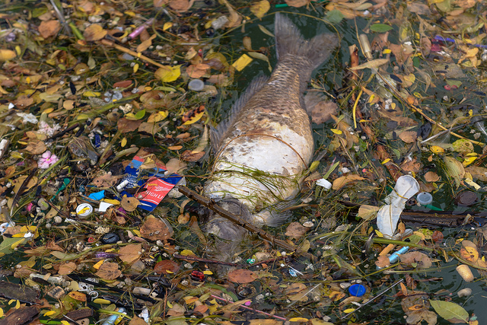
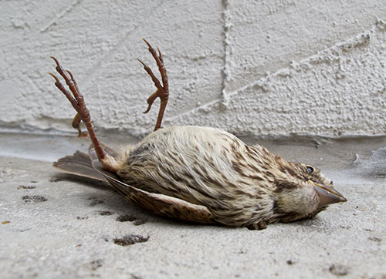

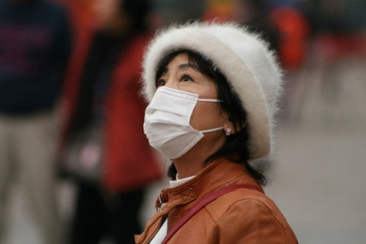
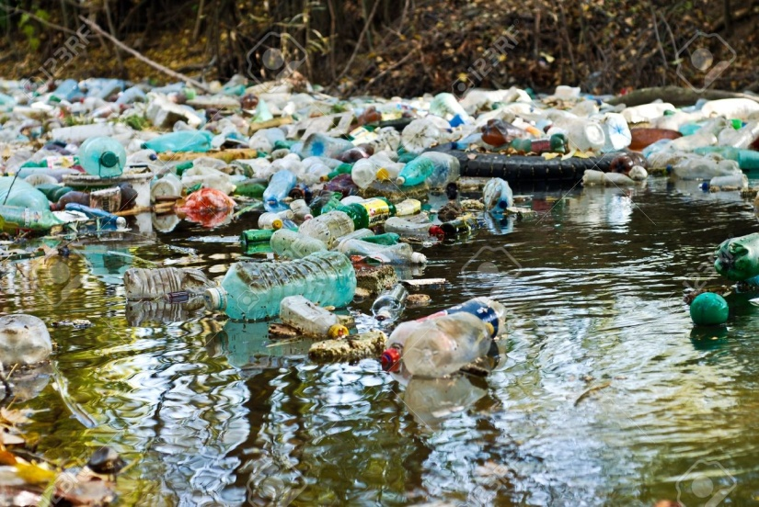

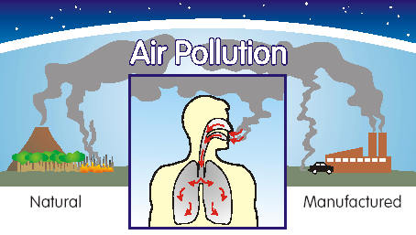







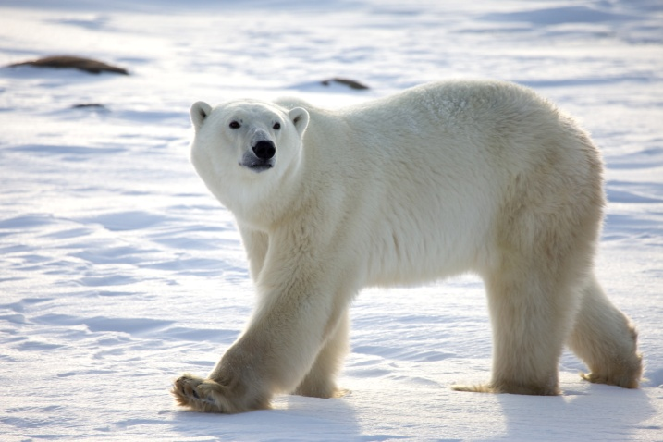



Worksheet
Listen and complete.
1. drank drunk sink draw sank saw

2.

3.

4. ___________________________________________________________________
___________________________________________________________________

5.

FORMAL ASSESSMENT TASK 3
ACTIVITY 2: READING AND VIEWING
___________________________________________________________________
DATE: ______________________________

Activity
READ A POEM

Form of assessment
Oral: Read out loud.

Assessment Tool:
Rubric

Recording and Reporting
Criteria | Marks | Learner’s Achievement
Demonstrates use of tone and inflection | 10
Convey meaning to the audience | 10
Use of voice and mastery of reading skills | 10
Use of eye / audience contact | 10
Responses to questions shows critical interpretation of the text | 10
Attitude and opinion shows critical interpretation of the text | 10
Prepared and confident | 10
TOTAL | 70÷70=1x15

Comment

_________________________________________________________________________________________________________________________________________________________________________________________________________
Rubric to assess prepared reading
Criteria | LEVEL 7 | LEVEL 6 | LEVEL 5 | LEVEL 4 | LEVEL 3 | LEVEL 2 | LEVEL 1
MARKS  15 | 10 – 8 | 7 | 6 | 5 | 4 | 3 | 2 – 0
Demonstrates use of tone and inflection | Reads expressively and creates atmosphere. Conveys feelings exceptionally well | Reads with very good expression and attempts made to convey feelings or atmosphere | Reads with good expression and attempts made to convey feelings or atmosphere | Makes an attempt to read with expression | Reads, but with limited expression | Meaning can be followed but not expression | Too poor to be expressive. Meaning lost
Convey meaning to the audience | Audience reaction shows a high degree of interest | Audience reaction largely showing interest and involvement | Audience reaction shows interest and involvement | Most members of the audience show interest | Some members of the audience show interest | Fails to capture the attention of most of the audience | Almost no interest from audience.
Use of voice and mastery of reading skills | Fluent, very entertaining reading  Excellent voice projection and diction which enhances meaning | Fluent reading  Very good voice projection and diction which enhances meaning | Reading fluency in a monotone  Good voice projection and diction which enhances meaning | Reads reasonably fluently  Reading is clear and audible and diction enhances meaning | Reads with limited fluency  Reading is audible and pronunciation does not affect meaning | Reading not fluent  Reading not always audible and many words are mispronounced | Halted reading  Poor pronunciation and poor delivery make the delivery almost incomprehensible
Use of eye / audience contact | Altogether appropriate eye-contact | Very good eye-contact | Good eye-contact | Successful efforts to make eye-contact | Eye-contact adequate | Unsuccessful attempts at making eye-contact | Almost no eye-contact
Responses to questions shows critical interpretation of the text | Handles questions with total confidence, ease and sensitivity to the text | Handles questions with confidence, ease and sensitivity to the text | Handles questions and responds sensibly with minor lapses | Handles questions and responds sensibly with lapses | Understand questions and can answer some of the questions | Understands questions and provides flawed answers | Is mostly unable to understand or respond to questions
Attitude and opinion shows critical interpretation of the text | Attitude and opinion confidently sustained and justified | Opinion well sustained and justified | Able to sustain opinion and justify it | Opinion reasonably confidently supported | Opinion sometimes adequately supported | Very hesitant to express an opinion | Unable to substantiate opinions
Prepared and confident | Reading is exceptionally well prepared and confident | Reader well prepared and reads with confidence | Reader prepared and reads with confidence | Reader is adequately familiar with the text – has made an effort to prepare | Limited amount of preparation. Reads with moderate confidence | Reader has not prepared the text. Obviously nervous | No evidence of preparation. Very nervous and demonstrates a lack of commitment
TOTAL | 70÷70=1x15

What to do
1. Read “A poem on climate change” out loud. Pay attention to reading skills.

TEXT: POEM
A poem on climate change

1. I don’t want my children to see the Earth die,
2. Without fish swim and without birds fly,
3. With no air for breathing, no water to drink,
4. When global conditions will make the land sink.

5. I don’t want emissions to stay in the air,
6. To fill our lungs and to spread everywhere,
7. To cause global warming, submerging the land!
8. To stop all this mess we should lend our hand!

9. The nature is dying together with us,
10. We wouldn’t exist here but for the green grass …
11. We must prevent nature from saying “farewell”-
12. In case it is dying, we’re dying as well!

13. What could human beings’ activities mean-
14. To make our planet one big rubbish bin?!
15. No matter that you may be only a teen –
16. It’s never too early or late to be green!

17. To show our children the beauty of life;
18. To help polar bears and pandas survive;
19. To claim to the world that this talk should gain weight
20. Let’s first take part in the global debate!
(by Julia Melnikova)

FORMAL ASSESSMENT TASK 3
ACTIVITY 3: READING COMPREHENSION
___________________________________________________________________
DATE: _________________________________

Activity
Answer questions based on a poem.

Form of assessment
Reading Comprehension.

Assessment Tool:
Memorandum

Recording and Reporting

Criteria | Marks | Learner’s Achievement
Reflect on reading material. Answer questions based on the poem. | 20

Comment

_________________________________________________________________________________________________________________________________________________________________________________________________________

What to do Did you know?
Air pollution includes greenhouse gases. One of these is carbon dioxide, a common part of the exhaust from cars and trucks. Greenhouse gases cause global warming by trapping heat from the Sun in the Earth's atmosphere.

1. Read “A poem on climate change”.
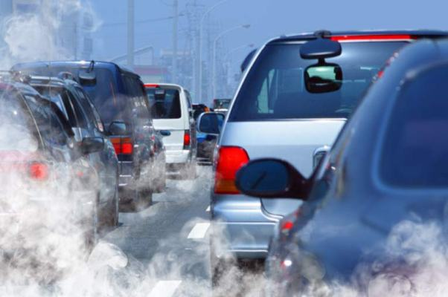
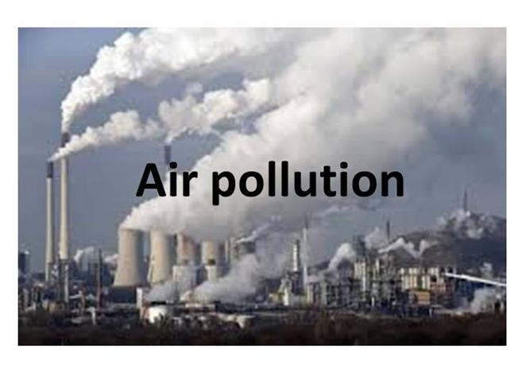
2. Answer the questions.

A poem on climate change

1. I don’t want my children to see the Earth die,
2. Without fish swim and without birds fly,
3. With no air for breathing, no water to drink,
4. When global conditions will make the land sink.

5. I don’t want emissions to stay in the air,
6. To fill our lungs and to spread everywhere,
7. To cause global warming, submerging the land!
8. To stop all this mess we should lend our hand!

9. The nature is dying together with us,
10. We wouldn’t exist here but for the green grass …
11. We must prevent nature from saying “farewell”-
12. In case it is dying, we’re dying as well!

13. What could human beings’ activities mean-
14. To make our planet one big rubbish bin?!
15. No matter that you may be only a teen –
16. It’s never too early or late to be green!

17. To show our children the beauty of life;
18. To help polar bears and pandas survive;
19. To claim to the world that this talk should gain weight
20. Let’s first take part in the global debate!
(by Julia Melnikova)
QUESTIONS
1. Use the words in the box and label the poem.
rhyme line stanza (3)

2. How many stanzas are there in this poem?
(1)

3. Identify the type of figurative language used in the sentence below, and then tick the word that describes it.
“I don’t want my children to see the Earth die” is an example of (1)
oxymoron |  | personification |  | hyperbole |  | metaphor

4. The poem starts with this line: “I don’t want my children to see the Earth die”. The poet then goes on to describe how the earth is being killed off. List four ways she says the earth is dying.
(4)

5. The poet starts the poem by saying what she doesn’t want for her children. In the last stanza she says what she does want for them: “To show our children the beauty of life”. What does she suggest we must do so we can achieve this?
(1)
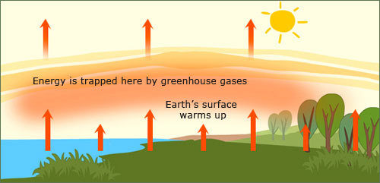

6. The poem’s title announces that the poem will be about climate change. But the poet also talks about pollution. Write down two types of pollution she speaks about.
(2)

7. Why does she do this? Do you think pollution and climate change are related? Explain why you think so.
(2)
8. Name two animals mentioned in the poem?
(1)
9. Write down the rhyming words in stanza 4.
(3)
10. Identify the figure of speech found in line 10 and tick the correct answer.
We wouldn’t exist here but for the green grass … (1)
assonance |  | metaphor |  | alliteration |  | simile

11. What is the message of this poem?
(1)

TOTAL (20)
FORMAL ASSESSMENT TASK 3
ACTIVITY 4: LANGUAGE STRUCTURES AND CONVENTIONS
___________________________________________________________________
DATE: _________________________________

Activity
Answer language questions based on a poem.

Form of assessment
Written presentation.

Assessment Tool:
Memorandum

Recording and Reporting

Criteria | Marks | Learner’s Achievement
Answer language questions based on a poem. | 20

Comment

_________________________________________________________________________________________________________________________________________________________________________________________________________

What to do.
Read extracts from the poem on page 11 and answer the Language questions.
1. Identify the common nouns in the extract and write them down.
I don’t want my children to see the Earth die,
Without fish swim and without birds fly …

(4)
2. Choose the correct part of speech for the underlined word in the sentence.
I would not like my children to see the earth die rapidly to the point of destruction.
a) adjective b) noun c) verb d) adverb e) preposition f) pronoun
(1)
3. Fill in the missing verbs (doing words) in the following extract.
With no air for __________________, no water to ___________,
When global conditions will make the land ______________.
(3)
4. Replace the following adjective (describing word) in the sentence with a suitable synonym from the list.
It might become so bad that (large) ______________________ areas of land will be covered by water as the polar ice caps melt.

small
green
huge
polluted
damaged
(1)
5. Match each word in column A with its meaning in column B. Write the correct word in the Answer column.
A | Answer column | B
global |  | discharge
emissions |  | flood
mess |  | worldwide
submerge |  | disorder
(4)
6. Change the two simple sentences to a compound sentence. Use the conjunction “because”
The earth is dying. We are destroying it.
______________________________________________________________________________________________________________________________________
(4)
7. Write the following sentence in the negative.
We are turning the earth into one big rubbish dump.
______________________________________________________________________________________________________________________________________
(2)
8. Write down the opposite word for ever.
______________________________________
(1)

TOTAL: (20)
FORMAL ASSESSMENT TASK 3
ACTIVITY 5: WRITING AND PRESENTING
___________________________________________________________________
DATE: __________________________________
Activity
Write a dialogue.

Form of assessment
Written presentation.

Assessment Tool:
Rubric

Recording and Reporting
Criteria | Marks | Achieved
Format: Uses features of a dialogue correctly | 10
Topic: Can complete dialogue according to the topic. | 10
Vocabulary: Uses suitable vocabulary to complete the dialogue. | 10
Transcription: Accurate | 10
Comprehension: Knows exactly what to do. | 10
Punctuation: Correct punctuation (colon, full stop etc) | 10
Spelling: Good spelling skills | 10
Presentation: Neat and legible | 10
TOTAL: | 80
PROCESSED MARK: (80÷4=20) | 20

Comment

_________________________________________________________________________________________________________________________________________________________________________________________________________
Rubric to assess a dialogue
DIALOGUE | Level 7 | Level 6 | Level 5 | Level 4 | Level 3 | Level 2 | Level 1
DIALOGUE | Outstanding | Meritorious | Substantial | Adequate | Moderate | Elementary | Not achieved
MARKS | 8-10 | 7 | 6 | 5 | 4 | 3 | 1-2
Format:
Uses features of a dialogue correctly
Topic:
Can complete dialogue according to the topic.
Vocabulary:
Uses suitable vocabulary to complete the dialogue.
Transcription:
Accurate
Comprehension:
Knows exactly what to do.
Punctuation:
Correct punctuation (colon, full stop etc)
Spelling:
Good spelling skills
Presentation:
Neat and legible
 | 80-100 | 70-79 | 60-69 | 50-59 | 40-49 | 30-39 | 0-29

What to do
1. Read the discussion between Sue and Dave about how to stop the climate from changing by taking care of the environment.
2. Use the discussion between Sue and Dave to write a dialogue. Pay attention to the correct format.
3. Use the information in the box to help you.
INFORMATION BOX
1. Dialogues are written in the direct speech.
2. There are no inverted commas. “................” x
3. Write the speakers name on the left hand side followed by a colon (:)
4. Write the dialogue on the right hand side.
5. Leave a line open between each speaker.

A discussion about climate change: Cartoon strip.
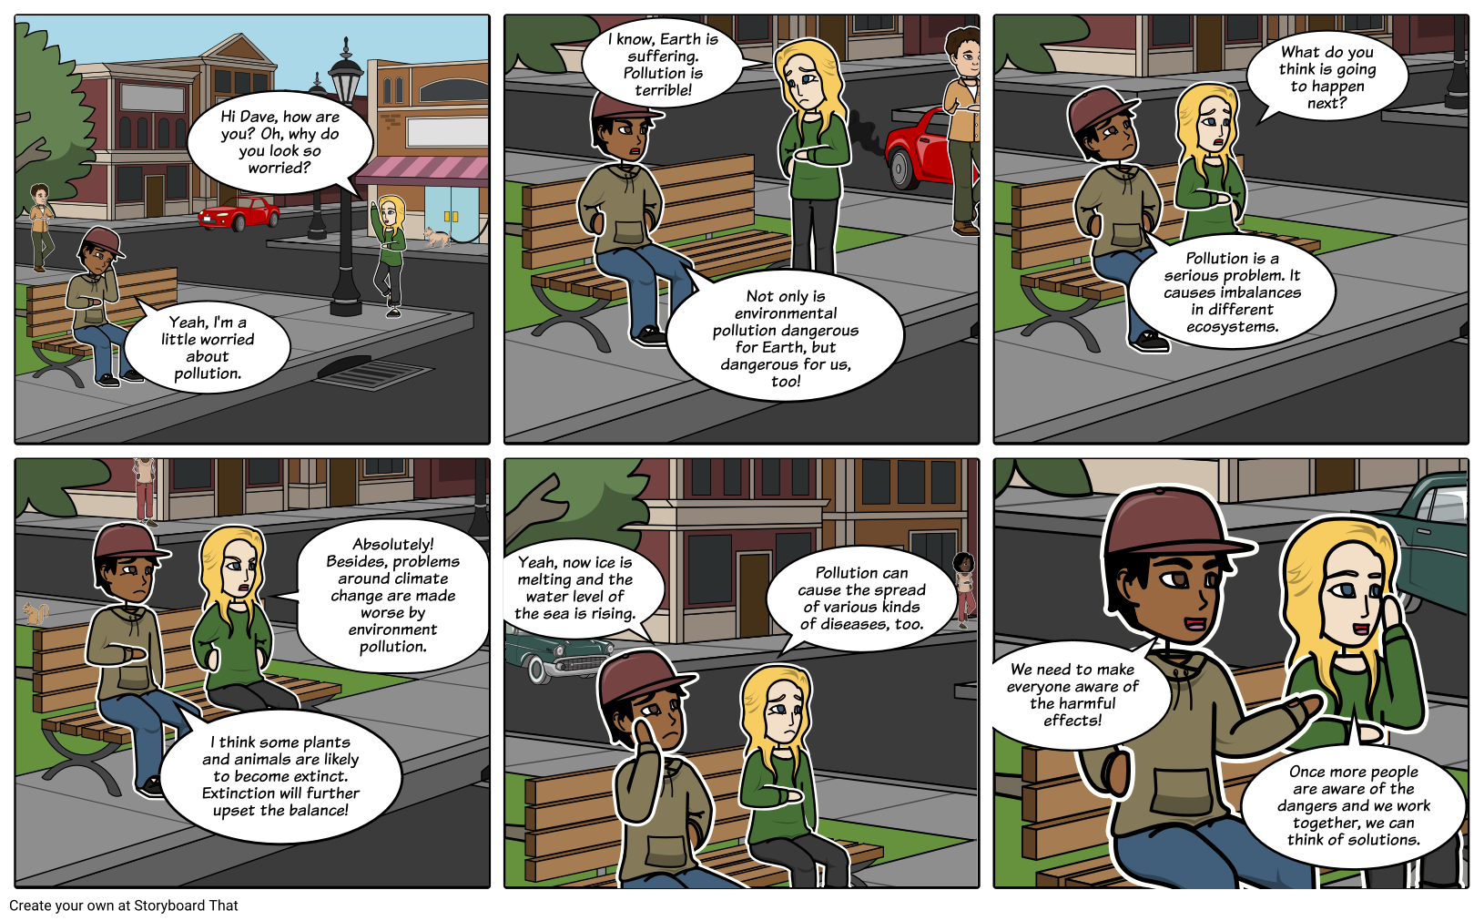

Write the following extract from the discussion in dialogue form.
Sue says, “Hi Dave, how are you? Oh, why do you look so worried?”
Dave replies, “Yeah, I’m a little worried about pollution.”
Sue approaches Dave and answers, “I know. Earth is suffering. Pollution is terrible!”
“Not only is environmental pollution dangerous for Earth, but dangerous for us, too!” exclaims Dave.
Sue joins Dave on the bench and asks, “What do you think is going to happen next?”
Dave responds, “Pollution is a serious problem. It causes imbalances in different ecosystems.”

Write your Dialogue here:

TOTAL: (20)

